Which of the following are correct about Redux **Stores?**

A: A store's state can be accessed by the store.getState(); function

B: A stores state can be updated by the store.dispatch(action) function

C: A store hold the application state

Ans: A,B,C

Which of the following statements are **correct** about props.children in React?

Options:

It contains the content between the opening and closing tags of the component

Children props are not available in stateless functional components

Children in React can be String leterals javascript expressions of JSX

Children can be a function which return JSX

In Css, how do you select all span elements within a p element?

* p.span
* p span
* span p
* span < p
* p > span

A twin of a word is a word written with the sam letters (case insensitive), but not in the same order

e.g Silent is a twin of Listen

function isTwin(a,b) {

return makeSortAndLowerCase(a) === makeSortAndLowerCase(b);

}

function makeSortAndLowerCase(str) {

return str.toLowerCase().split('').sort().join('');

}

console.log(isTwin('Silent', 'Listen')); // return true

My Dom document contains a navigation menu displayed as a header but at the top of the screen. I want that menu to stay at the top of the screen, even when the users scroll down

What is the value of the position CSS property I should add to this element to reach this goal?

* Fixed
* Absolute
* Static
* Inherit
* Relative

When sending an ajax request to a server what is the first method is to call on the XMLHttpRequest Object

* Run()
* Open()
* Execute()
* Connect()

var i = 3;

function change(j) {

j = 4;

}

change(i);

console.log(i);

* undefined
* 3
* 4
* Nothing, an error will occur
* NaN

Write the body of the function isOnEvenPosition(table, value), the function should return true if value is contained in table at an even index, false otherwise

e.g.

var t = [9,8, 7, 6, 5, 4, 3, 2, 1, 0];

print(isOnEvenPosition(t, 6)) // false

print(isOnEvenPosition(t, 3)) // true

<div class="parent">

<div class="d1">

first div hello

</div>

<div class="d2">

second div hello

</div>

<div class="d3">

third div hello

</div>

</div>

.parent{

display: flex

}

.d1 {

flex: 10;

}

.d2 {

flex: 10;

}

.d3 {

flex: 20;

}

The Parent div is inline

The three div are laid out horizontally

The three div are laid out vertically

The div d2 take up 20% of the parent width

The code is invalid

The div d2 takes up the twice the parent width

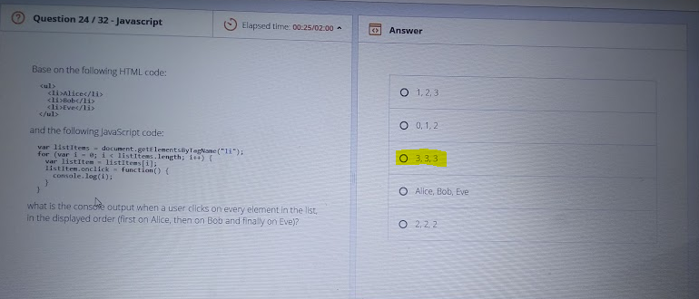

React life cycle hooks

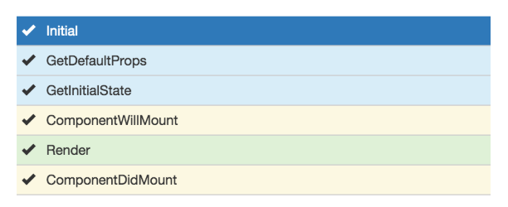

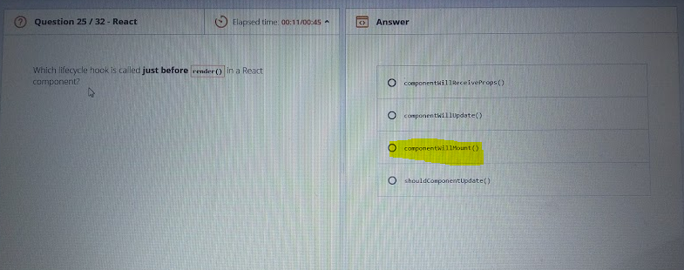

**Q 26.** Which of the following statement is correct regarding context in react?

* Context can be referenced from a child component by the this.getContext() function
* Context can be passed down the component tree by defining **childContextTypes** and **getChildContext** on the parent component
* Context can not be accessed in stateless functional component
* Context if defined cannot be accessed in lifecycle method

Which of the following statements are correct with respect to following code snippet

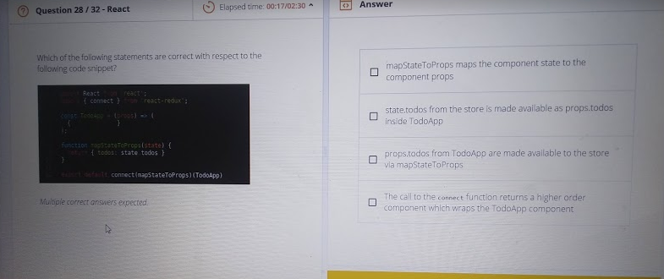

// Next Question 31

var MyClass = function(n) {

this.n = n;

}

MyClass.square = function() {

return this.n * this.n;

}

var obj = new MyClass(4);

console.log(obj.square());

* function() { return this.n * this.n; }
* An error
* 16